**LAB # 05 II**

**SUPERVISED LEARNING (LINEAR REGRESSION)**

**OBJECTIVE**

Implementing supervised learning, linear regression algorithm for training, testing and classification.

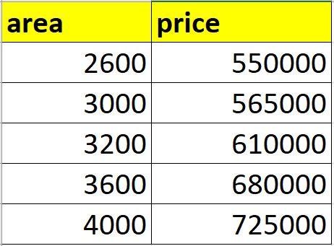

1.implement linear regression algorithm on above dataset predict price of home with areas in the dataset by using (homeprices.csv).

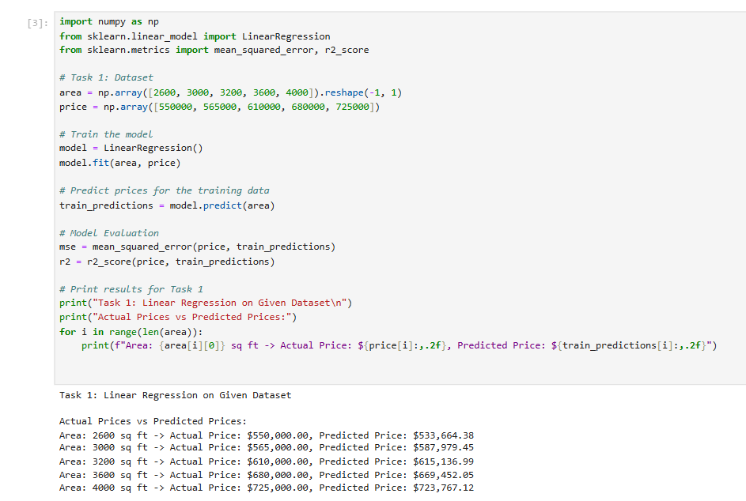

2.implement Implement linear regression using table 1 in such a way that the

**Predict price of a home with area = 5000 sqr ft**

**Predict price of a home with area = 8000 sqr ft**

**Predict price of a home with area = 9000 sqr ft**



